

**Site Reliability Troubleshooting with Cloud Monitoring APM [ACE]**

1 hour 30 minutes Free

Rate Lab

**Overview**

The objective of this lab is to familiarize yourself with the specific capabilities of Cloud Monitoring to monitor GKE cluster infrastructure, Istio, and applications deployed on this infrastructure.

**What you'll do**

* Create a GKE cluster
* Deploy a microservices application to it
* Define latency and error SLIs and SLOs for it
* Configure Cloud Monitoring to monitor your SLIs
* Deploy a breaking change to the application and use Cloud Monitoring to troubleshoot and resolve the issues that result
* Validate that your resolution addresses the SLO violation

**What you'll learn**

* How to deploy a microservices application on an existing GKE cluster
* How to select appropriate SLIs/SLOs for an application
* How to implement SLIs using Cloud Monitoring features
* How to use Cloud Trace, Profiler, and Debugger to identify software issues

**Prerequisites**

* Google Cloud Platform account and project with billing account
* Basic knowledge of Kubernetes
* Basic knowledge of Cloud Monitoring
* Basic knowledge of troubleshooting process

**Environment Setup**

For each lab, you get a new GCP project and set of resources for a fixed time at no cost.

1. Make sure you signed into Qwiklabs using an **incognito window**.
2. Note the lab's access time (for example, img/time.pngand make sure you can finish in that time block.

There is no pause feature. You can restart if needed, but you have to start at the beginning.

1. When ready, click img/start_lab.png.
2. Note your lab credentials. You will use them to sign in to Cloud Platform Console. 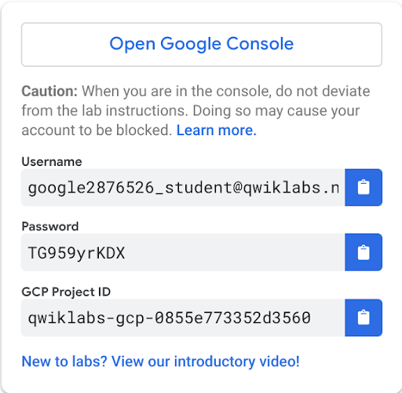
3. Click **Open Google Console**.
4. Click **Use another account** and copy/paste credentials for **this** lab into the prompts.

If you use other credentials, you'll get errors or **incur charges**.

1. Accept the terms and skip the recovery resource page.

Do not click **End Lab** unless you are finished with the lab or want to restart it. This clears your work and removes the project.

**Activate Google Cloud Shell**

Google Cloud Shell is a virtual machine that is loaded with development tools. It offers a persistent 5GB home directory and runs on the Google Cloud. Google Cloud Shell provides command-line access to your GCP resources.

1. In GCP console, on the top right toolbar, click the Open Cloud Shell button.

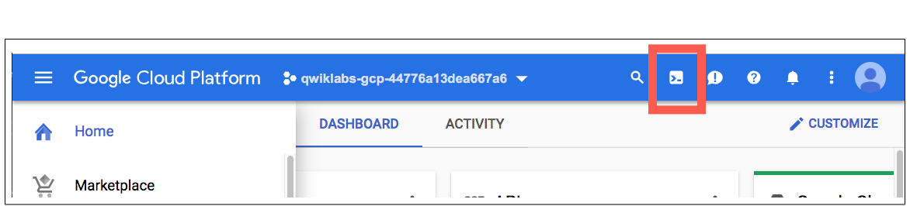

1. Click **Continue**. 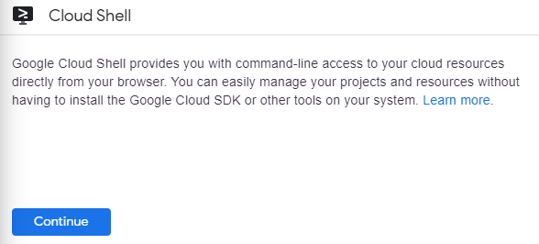

It takes a few moments to provision and connect to the environment. When you are connected, you are already authenticated, and the project is set to your *PROJECT\_ID*. For example:

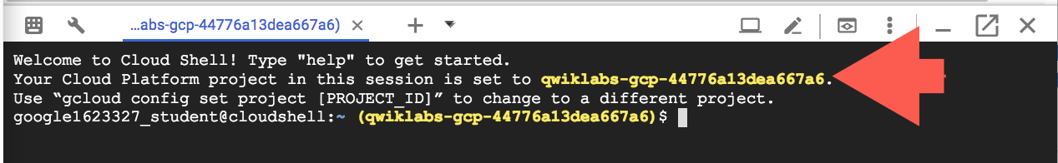

**gcloud** is the command-line tool for Google Cloud Platform. It comes pre-installed on Cloud Shell and supports tab-completion.

You can list the active account name with this command:

gcloud auth list

Output:

Credentialed accounts:

- <myaccount>@<mydomain>.com (active)

Example output:

Credentialed accounts:

- google1623327\_student@qwiklabs.net

You can list the project ID with this command:

gcloud config list project

Output:

[core]

project = <project\_ID>

Example output:

[core]

project = qwiklabs-gcp-44776a13dea667a6

Full documentation of **gcloud** is available on [Google Cloud gcloud Overview](https://cloud.google.com/sdk/gcloud) .

**Infrastructure setup**

In this lab you will connect to a Google Kubernetes Engine cluster and validate that it's been created correctly.

Set the zone in gcloud:

gcloud config set compute/zone us-west1-b

Set the project ID:

export PROJECT\_ID=$(gcloud info --format='value(config.project)')

Verify that the cluster named shop-cluster has been created:

gcloud container clusters list

Your cluster status will say PROVISIONING. Wait a moment and run the command above again. Repeat until the status is RUNNING. This could take several minutes.

While you're waiting, set up your Monitoring workspace to monitor the application on your cluster.

**Create a Monitoring workspace**

You will now setup a Monitoring workspace that's tied to your Qwiklabs GCP Project. The following steps create a new account that has a free trial of Monitoring.

1. In the Google Cloud Platform Console, click on **Navigation menu** > **Monitoring**.
2. Wait for your workspace to be provisioned.

When the Monitoring dashboard opens, your workspace is ready.

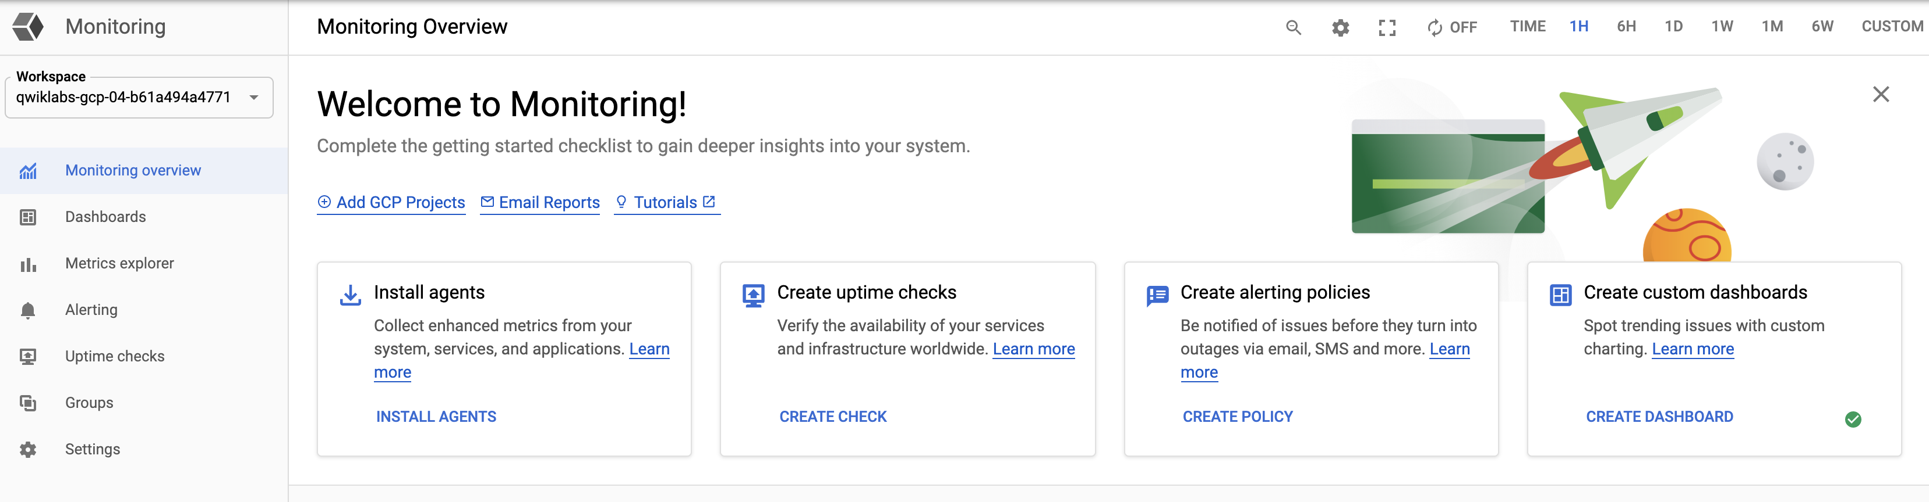

Go back to your Cloud Shell and check again to see if the cluster has finished provisioning:

gcloud container clusters list

Once your cluster has RUNNING status, get the cluster credentials:

gcloud container clusters get-credentials shop-cluster --zone us-west1-b

Your output should look like this:

Fetching cluster endpoint and auth data.

kubeconfig entry generated for shop-cluster.

Verify that the nodes have been created:

kubectl get nodes

Your output should look like this:

NAME STATUS ROLES AGE VERSION

gke-shop-cluster-demo-default-pool1-24748028-3nwh Ready <none> 4m v1.13.7-gke.8

gke-shop-cluster-demo-default-pool1-24748028-3z1g Ready <none> 4m v1.13.7-gke.8

gke-shop-cluster-demo-default-pool1-24748028-4ksd Ready <none> 4m v1.13.7-gke.8

gke-shop-cluster-demo-default-pool1-24748028-f2f2 Ready <none> 4m v1.13.7-gke.8

gke-shop-cluster-demo-default-pool1-24748028-gcb3 Ready <none> 4m v1.13.7-gke.8

**Deploy application**

In this module, you will deploy a microservices application called Hipster Shop to your cluster to create an actual workload you can monitor.

Run the following to clone the repo:

git clone https://github.com/GoogleCloudPlatform/training-data-analyst

Create a soft link to your working directory:

ln -s ~/training-data-analyst/blogs/microservices-demo-1 ~/microservices-demo-1

Download and install skaffold:

curl -Lo skaffold https://storage.googleapis.com/skaffold/releases/latest/skaffold-linux-amd64 && chmod +x skaffold && sudo mv skaffold /usr/local/bin

Install the app using skaffold:

cd microservices-demo-1

skaffold run

Confirm everything is running correctly:

kubectl get pods

Your output should look like this:

NAME READY STATUS RESTARTS AGE

adservice-55f94cfd9c-4lvml 1/1 Running 0 20m

cartservice-6f4946f9b8-6wtff 1/1 Running 2 20m

checkoutservice-5688779d8c-l6crl 1/1 Running 0 20m

currencyservice-665d6f4569-b4sbm 1/1 Running 0 20m

emailservice-684c89bcb8-h48sq 1/1 Running 0 20m

frontend-67c8475b7d-vktsn 1/1 Running 0 20m

loadgenerator-6d646566db-p422w 1/1 Running 0 20m

paymentservice-858d89d64c-hmpkg 1/1 Running 0 20m

productcatalogservice-bcd85cb5-d6xp4 1/1 Running 0 20m

recommendationservice-685d7d6cd9-pxd9g 1/1 Running 0 20m

redis-cart-9b864d47f-c9xc6 1/1 Running 0 20m

shippingservice-5948f9fb5c-vndcp 1/1 Running 0 20m

Re-run the command until all pods are reporting a Running status before moving to the next step.

Get the **external IP** of the application:

export EXTERNAL\_IP=$(kubectl get service frontend-external | awk 'BEGIN { cnt=0; } { cnt+=1; if (cnt > 1) print $4; }')

Finally, confirm that the app is up and running:

curl -o /dev/null -s -w "%{http\_code}\n" http://$EXTERNAL\_IP

**Note:** You may need to run this command a second time if you get a 500 error.

Your confirmation will look like this:

200

Download the source and put the code in the Cloud Source Repo:

./setup\_csr.sh

Now that the application has been deployed, set up monitoring for the application.

**Resources**

* [Microservices Demo Application](https://github.com/GoogleCloudPlatform/microservices-demo)

NOTE: This lab uses a [fork](https://github.com/blipzimmerman/microservices-demo-1) of this application build to aid in the troubleshooting exercises.

* [Skaffold](http://skaffold.dev)

**Develop Sample SLOs and SLIs**

Before implementing any monitoring, review the introduction to the chapter on Service Level Objectives from the SRE [Book](https://landing.google.com/sre/books/):

It's impossible to manage a service correctly, let alone well, without understanding which behaviors really matter for that service and how to measure and evaluate those behaviors. To this end, we would like to define and deliver a given level of service to our users, whether they use an internal API or a public product.

We use intuition, experience and an understanding of what users want to define **service level indicators (SLIs)**, **objectives (SLOs)** and **agreements (SLAs)**. These measurements describe basic properties of metrics that matter, what values we want those metrics to have and how we'll react if we can't provide the expected service. Ultimately, choosing appropriate metrics helps to drive the right action if something goes wrong and also gives an SRE team confidence that a service is healthy.

An SLI is a service level indicator: A carefully defined quantitative measure of some aspect of the level of service that is provided.

Most services consider

**request latency**: how long it takes to return a response to a request as a key SLI. Other common SLIs include the **error rate**, often expressed as a fraction of all requests received and **system throughput**, typically measured in requests per second. Another kind of SLI important to SREs is **availability** or the fraction of the time that a service is usable. It is often defined in terms of the fraction of well-formed requests that succeed.

**Durability**: the likelihood that data will be retained over a long period of time is equally important for data storage systems. The measurements are often aggregated: i.e., raw data is collected over a measurement window and then turned into a rate, average, or percentile.

Now that you have established a basic understanding, define the SLIs and SLOs for your application. Given that the application itself serves end user ecommerce traffic, it's going to be very important that user experience remains constant and that performance is good. You will monitor SLIs for request latency, error rate, throughput and availability.

**Application Architecture**

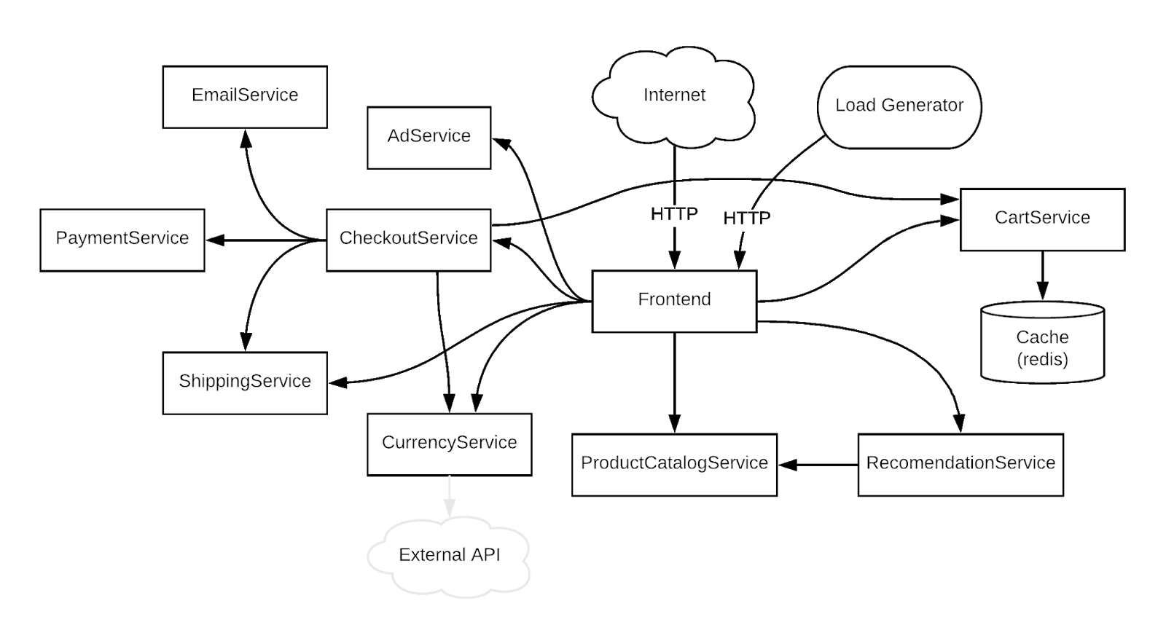

It's impossible to develop SLIs without understanding how the application is built. Details are in the original [repository](https://github.com/GoogleCloudPlatform/microservices-demo), but for this lab, it suffices to understand that:

* Users access the application through the Frontend.
* Purchases are handled by CheckoutService.
* CheckoutService depends on CurrencyService to handle conversions.
* Other services such as RecommendationService, ProductCatalogService and Adservice are used to provide the frontend with content needed to render the page.

**Service Level Indicators and Objectives**

The following SLIs and SLOs are selected based on the end-user experience and the theoretical impact to users and business objectives.

|  |  |  |  |
| --- | --- | --- | --- |
| **SLI** | **Metric** | **Description** | **SLO** |
| Request latency | Front end latency | Measures how long a user is waiting for the page to load. A high latency typically correlates to a negative user experience | 99% of requests from the previous 60 minute period are services in under 3 seconds |
| Error rate | Front end error rate | Measures the error rate experienced by users. A high error rate likely indicates an issue. | 0 Errors in the previous 60 minute period |
| Error rate | Checkout error rate | Measures the error rate experienced by other services calling the checkout service. A high error rate likely indicates an issue. | 0 Errors in the previous 60 minute period |
| Error rate | Currency Service error rate | Measures the error rate experienced by other services calling the currency service. A high error rate likely indicates an issue. | 0 Errors in the previous 60 minute period |
| Availability | Front end success rate | Measures the rate of successful requests as a way to determine the availability of the service. A low success rate likely indicates that users are having a poor experience. | 99% of requests are successful over the previous 60 minute period |

**Configure Latency SLI**

Now that you have SLOs and SLIs defined, you can implement cloud monitoring. The metrics you are interested in are already being collected. You will create alerting policies for each of your SLOs.

**Front End Latency**

In the Monitoring tab, click **Alerting** and select **Create Policy**.

Name the policy **Latency Policy**.

Click **Add Condition** and specify the metric and condition that will be used to trigger the Alerting Policy. The condition will let you know when you're experiencing performance issues that are impacting user experience.

As described in the *Service Level Indicators and Objectives* table above, you will use the 99th percentile front end latency as the SLI.

Add the following into the **Find resource type and metric** field then select the following from the dropdown menu:

custom.googleapis.com/opencensus/grpc.io/client/roundtrip\_latency

**Note:** You may need to refresh the page to see the above metric.

In the Resource Type, select the **Global** option.

Click into the **Filter** field and select the **opencensus\_task** item. Click on the first default Value, then click **Apply**.

Next, set the Aggregator to **99th percentile**.

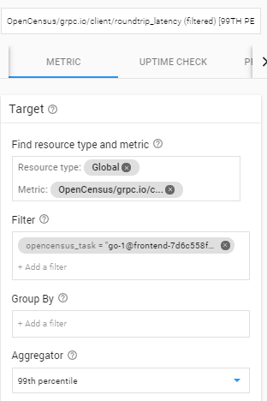

Next, in the **Configuration** area, set the options as follows:

* Condition triggers if **Any time series violates**
* Condition: **is above**
* Threshold: **500**
* For: **Most recent value**

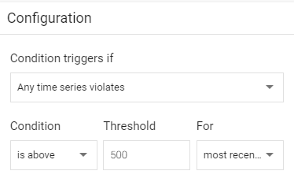

Click **Add**.

Click **Save**. You've configured Cloud Monitoring to monitor your frontend latency SLI!

**Configure Availability SLI**

Next, configure Cloud Monitoring to monitor service availability by creating another Alerting Policy.

**Front End Availability**

Start by monitoring the error rate for the front end service, since that’s where user experience is going to be most directly impacted. As discussed above, you’re going to consider any failures observed to be an SLO violation. Create an alerting policy that will trigger an incident if any failures are observed.

An easy way to trigger on a particular failure is to use log-based metrics.

In the Google Cloud Platform Console, click **Logging**.

Configure the filter as follows:

* In Resource type select **Kubernetes Container**.
* In Any Log Level select **ERROR**.
* In the filter bar add: label:k8s-pod/app:"currencyservice"

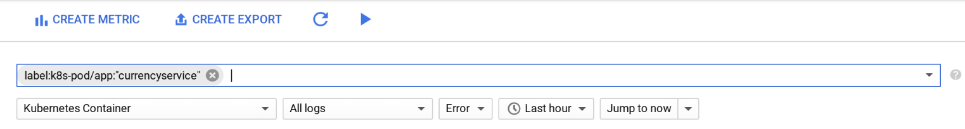

Click **Create Metric**.

Name the metric Error\_Rate\_SLI and click **Create Metric** to save the log based metric:

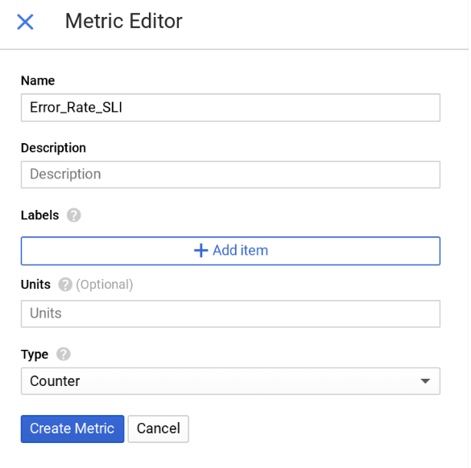

You now see the metric listed on the Logs-based metrics page. To create an alert for this metric, click the 3 dots at the end of the row and select **Create Alert from Metric**.

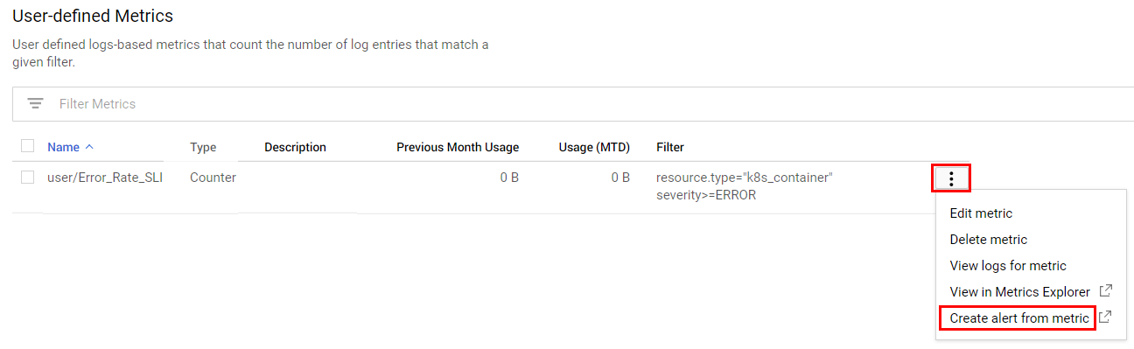

Notice the resource type and metric have already been filled in.

Name the condition "Error Rate SLI".

Click the **Show Advanced Options** link and set the following:

* Aligner: **rate**

In Configuration, use **0.5** as your Threshold for **1 minutes**.

Then **Save** the condition.

In the subsequent screen, name your new policy "Error Rate SLI", and **Save** it.

As expected, there are no failures, and your application is currently meeting its availability SLO!

**Deploy new release**

Now that you have configured SLI monitoring, you're ready to measure the impact of application changes on user experience. See what happens when you deploy a new release of the application.

Next you'll modify the Kubernetes manifests for the services which have new releases and then run skaffold to deploy the application again.

**Update YAML files**

Open the Code Editor in Cloud Shell:

ba731110a97f468f.png

Find the **microservices-demo-1** folder and open the **kubernetes-manifests** folder within it.

**Update** the kubernetes manifests to pull the new images by:

1. Replacing the **accl-demo** image tag with **rel013019**
2. Adding: imagePullPolicy: Always

in the following files:

* kubernetes\_manifests/recommendationservice.yaml
* kubernetes\_manifests/currencyservice.yaml
* kubernetes\_manifests/frontend.yaml

As an example, here's the original version of the recommendationservice.yaml file:

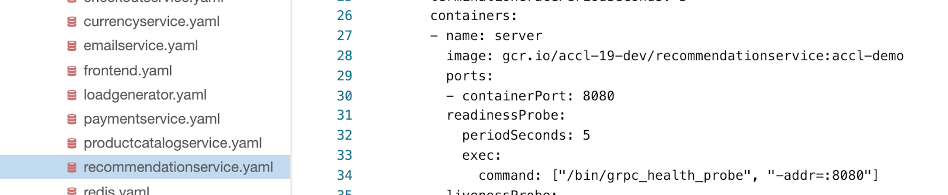

And here it is after making the update:

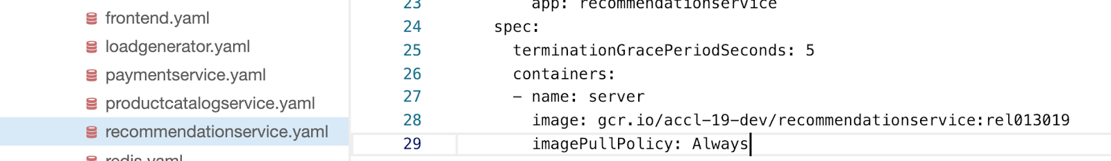

Once you've updated and closed each of the files, you're ready to deploy the new version!

**Deploy New Version**

In Cloud Shell, update the deployment to deploy the new container image:

skaffold run

Validate that there are new versions of services running:

kubectl get pods

Your output should look like this:

NAME READY STATUS RESTARTS AGE

adservice-55f94cfd9c-4lvml 1/1 Running 0 17d

cartservice-6f4946f9b8-6wtff 1/1 Running 197 17d

checkoutservice-5688779d8c-l6crl 1/1 Running 0 17d

currencyservice-665d6f4569-b4sbm 1/1 Running 0 1m

emailservice-684c89bcb8-h48sq 1/1 Running 0 17d

frontend-5f889fc7bb-wvfvv 1/1 Running 0 1m

loadgenerator-6d646566db-p422w 1/1 Running 0 17d

paymentservice-858d89d64c-hmpkg 1/1 Running 0 17d

productcatalogservice-bcd85cb5-d6xp4 1/1 Running 0 17d

recommendationservice-57cb4559f9-bdgj7 1/1 Running 0 1m

redis-cart-9b864d47f-c9xc6 1/1 Running 0 17d

shippingservice-5948f9fb5c-vndcp 1/1 Running 0 17d

**Send some data**

Now that the application is running, go look at what you have deployed.

In the Console, navigate to **Kubernetes Engine** > **Services & Ingress**. Look for the frontend-external service and click on the Endpoint URL.

Once on the Hipster Shop website, click on a **Buy** and/or **Add to Cart** for a couple of items to send some traffic.

**Latency SLO Violation - Find the Problem**

In this exercise you will use Cloud Application Performance Management tools (APM) to identify and resolve an issue causing poor application latency.

First see if everything is still OK with the application after deploying the new version.

Go to **Monitoring Overview** page. Click the **autorefresh arrows** in the top ribbon so you will always be looking at the latest information.



A Latency Policy incident appears shortly if it hasn't already, please wait a few minutes to see it show up.

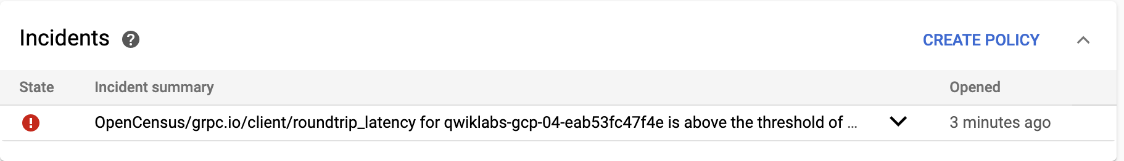

To learn more about what's going on, click Alerting in the left menu, and then click the alert in the Incidents section. You may need to click on the **Acknowledge Incident** to see that the alert happened. The best way to analyze latency issues is by using Trace. In the Google Cloud Platform Console, click **Trace**.

You're now in the Console. The initial overview is useful, but you need to get to the next level of detail. Open the **Trace List** page.

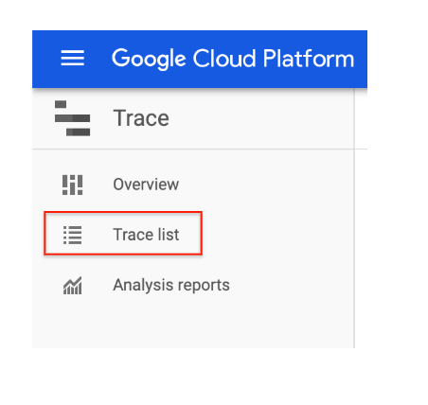

Click **Auto Reload**. Notice the scatter plot at the top of the page and that, around the time of the alert, there are a large number of outlier requests.

Wait a minute or two, to gather data, then click on one of the outlier traces to see the specifics about what is going on.

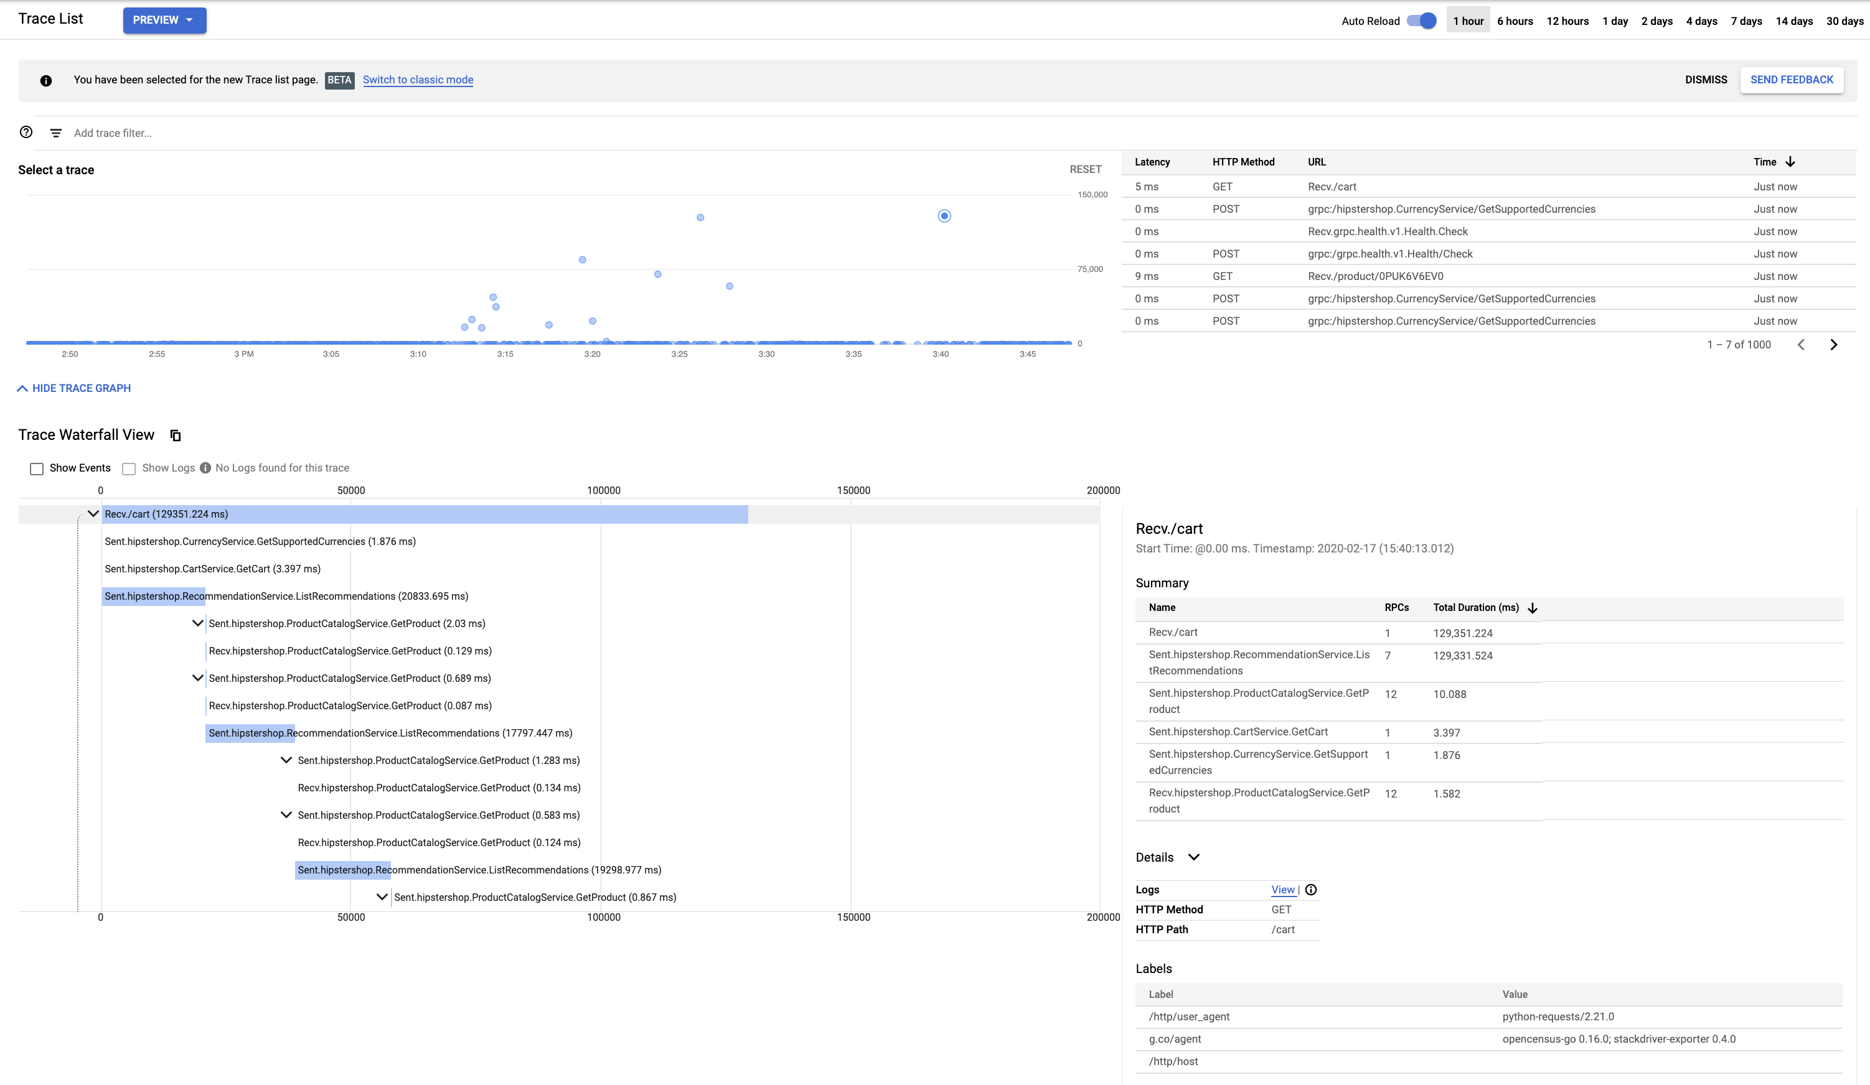

Notice the Span name (which represents the service or function that is being called) is either /cart/ or /cart/checkout/.

To help understand how this trace compares with similar ones prior to the issue, look at the Recv./cart Summary in the lower left for all the cart operations and look for similar traces.

Set the time period to **1 hour** so that it includes traces that occurred before the issue.

64c6982957db838c.png

Click on an example trace from before the issue occurred

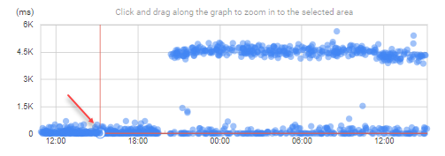

Notice that in this similar trace ListRecommendations was only called once. However, after the most recent deploy, ListRecommendations is being called many times per request, causing significant additional latency.

You can conclude that the issue with these outliers is caused by multiple calls to ListRecommendations.

**Deploy Change to Address Latency**

In order to address the latency issue that the last release created, you need to roll out another version that fixes the broken code. You will next modify the Kubernetes manifests for the services that contained the broken code.

To deploy a fix return to Cloud Shell and open the **Source Code Editor**. You'll be modifying the following files:

* kubernetes\_manifests/recommendationservice.yaml
* kubernetes\_manifests/frontend.yaml

Modify the image tag **rel013019** with **rel013019fix** so the image should look like this:

containers:

- name: server

image: gcr.io/accl-19-dev/frontend:rel013019fix

imagePullPolicy: Always

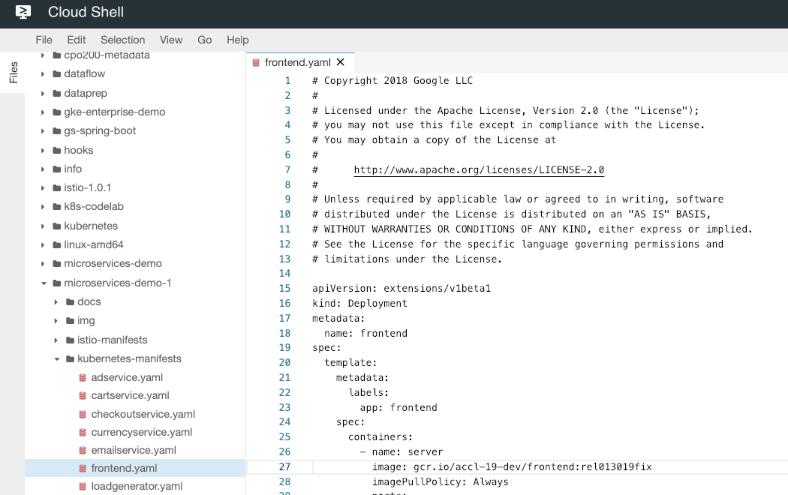

**Save** the files.

Return to the Cloud Shell prompt and redeploy the images with the fixes in them:

skaffold run

**Validate Fix**

Now that you've rolled back the breaking change, verify that your application is back to a healthy state.

Return to **Monitoring** and click **Metrics Explorer**.

In the search field, enter **roundtrip latency** and select custom.googleapis.com/opencensus/grpc.io/client/roundtrip\_latency.

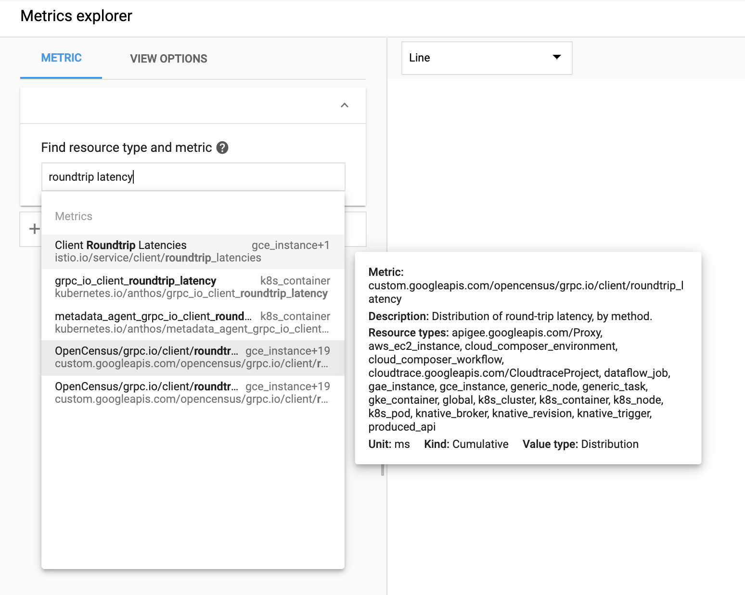

Select **Global** as a resource type. Click **here** link in the **Aggregator** field.

Change the chart type to **Line**. You should see a chart that shows an immediate decrease in latency (and if you don't, wait a minute).

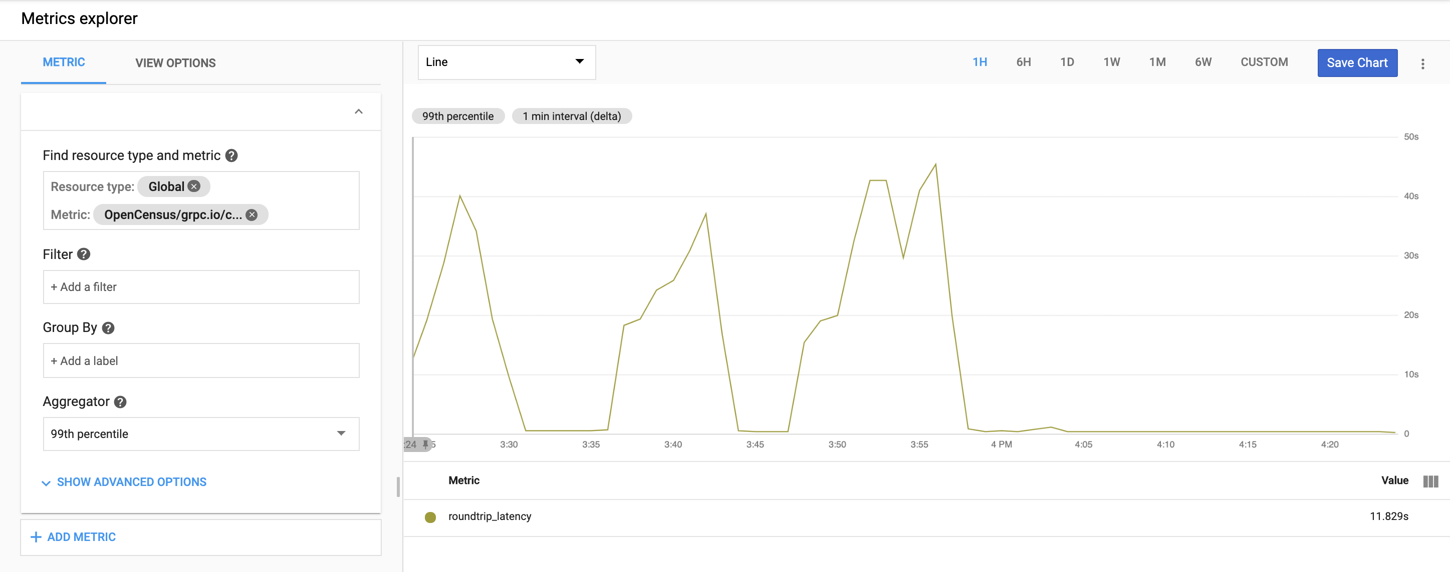

Now, see if the incidents are resolved. Return to the **Monitoring Overview**.

You should notice two things - you no longer have an incident and there are events letting you know that the incident has been resolved. Again, if you don't see an Incident resolved message, wait a couple of minutes.

Your monitoring was able to correctly identify a change that caused user experience (as measured by latency) to degrade, you were able to identify the root cause and you've rolled back the breaking change! In the next section, see how Monitoring can help you resolve an issue with availability.

**Error Rate SLO Violation - Find the Problem**

In this exercise you will use Cloud Monitoring Application Performance Management tools (APM) to troubleshoot an issue causing ERRORs in your application violating your error budget.

Click **Alerting** in Monitoring.

Look for a Error Rate SLI incident and click the **incidents** to learn more about what's going on. Incidents can take several minutes to be confirmed and listed as an incident. If an incident has not yet arrived, you can skip the Incident step below click on **Error Reporting** in the GCP console.

You can see that the pod is logging significantly more errors than it was previously.

**Acknowledged** the incident so that no further notification escalation takes place.

For an alert like this there are many places to start, but the easiest is Error Reporting.

Notice the Open Error Reporting incidents with a recent spike in occurrences. Click on the **Error: Conversion is Zero** to learn more about the error in question.

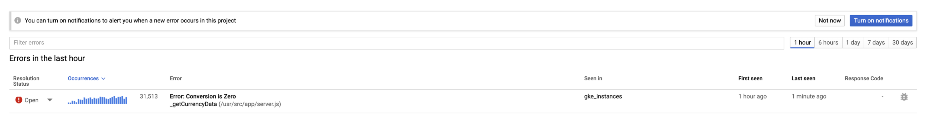

Look at the Stack Trace sample on the right. Here you can see what specific calls were related to the error. 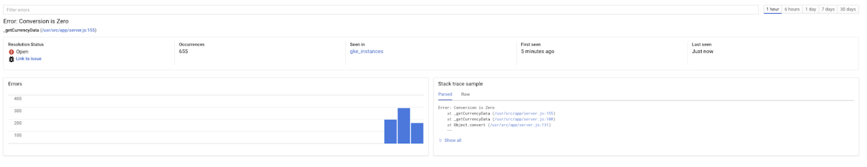

**Click** on the lowest call showing here: **/usr/src/app/server/js:131**

This will load you into Debugger. On the top bar click the **Service** and select the **currencyservice**.

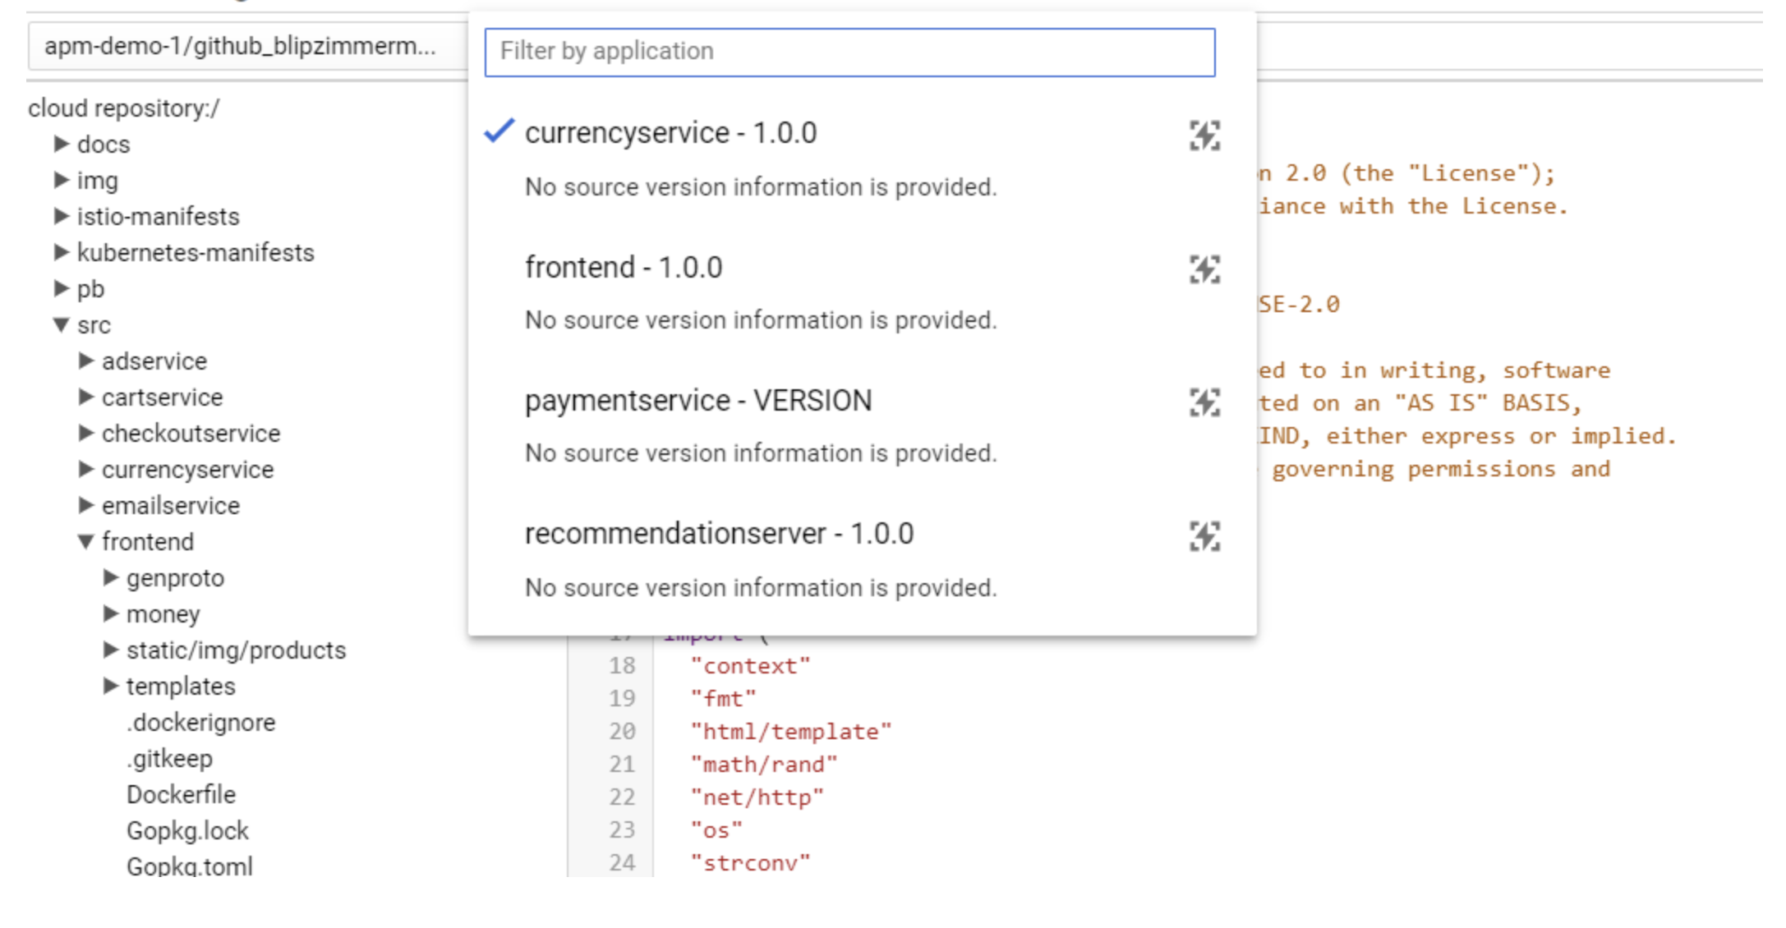

Next, select the source code that is running from **Cloud Source Repositories**.

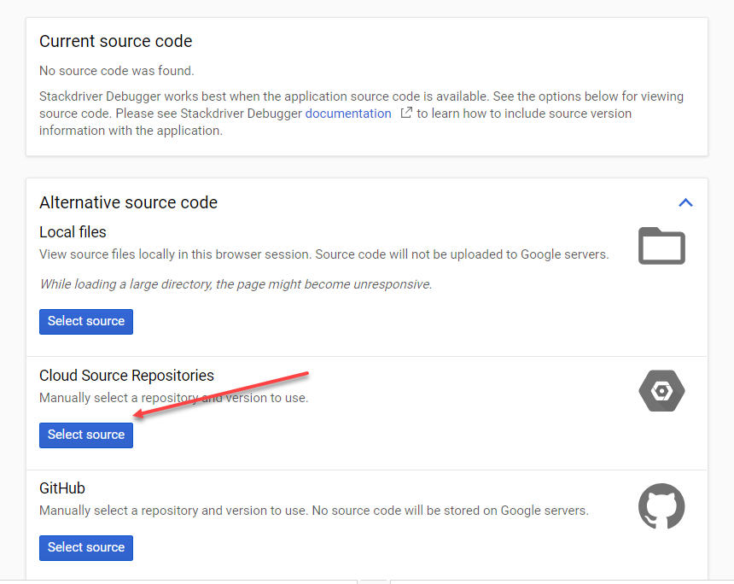

Select your source with:

* **Repository:** apm-qwiklabs-demo
* **Tagged version or branch:** APM-Troubleshooting-Demo-2

Then click **Select Source**.

In the left hand menu browse to /src/currencyservice/server.js.

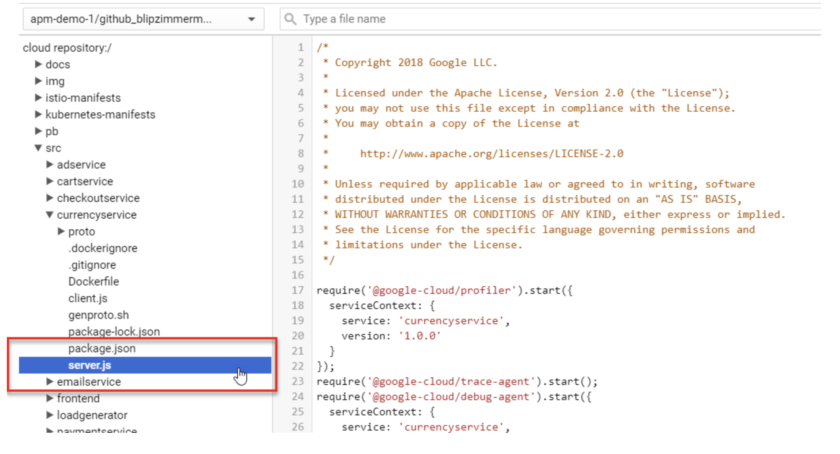

Scroll down to around line 155 which is the function where the exception was thrown. You can see the logline **Conversion is Zero** that was referenced in error reporting.

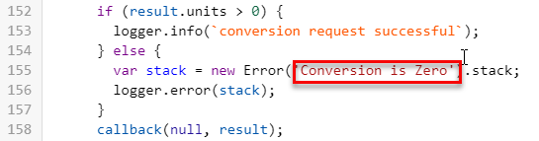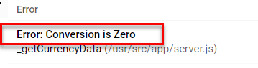

From the above code snippet you see this error is logged when result.units < 0. To troubleshoot this issue you'll use Snapshots to inspect the variables as the application progresses.

Make sure you have selected **Snapshot** in the top right:

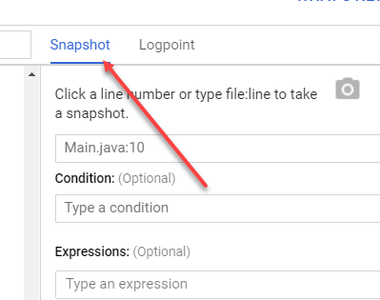

Then click on the line number (155) you want to snapshot:

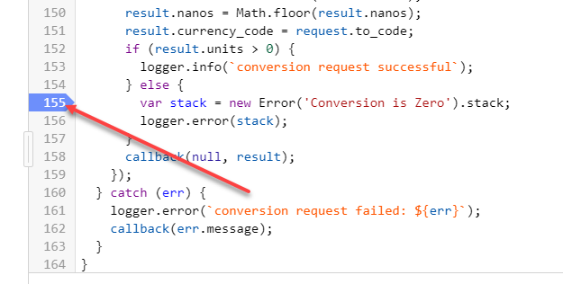

For this exercise take snapshots at line 155, 141 and 149. Add additional snapshot points wherever you feel appropriate. The system will take a variable snapshot the next time that code is executed. While the application is waiting for the code to be executed next you can see a "Waiting for snapshot to hit...." notice.

When the snapshot is complete the right hand pane will display the variables for that given snapshot.

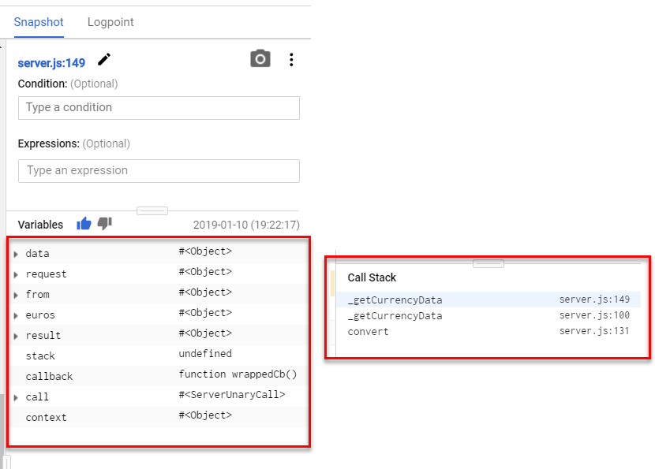

Notice the Variable and Call Stack information. This information can provide extremely deep understanding of the path you code is taking including the variables and structures that exist as it takes that path, all without restarting the application or changing any code.

Click **result** to inspect all 3 snapshots finishing on line 155. Remember the error is triggered when result.units is NOT > 0. Inspecting the variables you can see that result.units = NaN (meaning ‘not a number'). This is the issue that is causing the error.

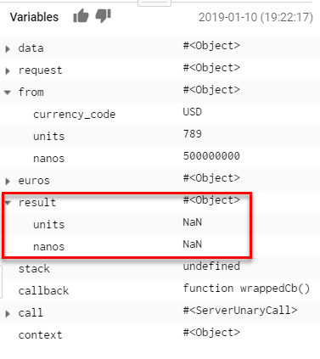

At this point you can conclude that the error is caused by a bug in the convert (or child) functions which sets the result.units to 0 resulting in a 0.00 price tag for the item being converted. Your troubleshooting along with the snapshot information and logs is a solid diagnosis of the issue.

So what is the bug that has caused this problem? From the code, result.units is set by the line 144 from euros, which was set in line 136 by operating on from.units

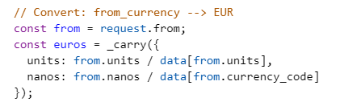

Inspecting the snapshots euros.units is also NaN, however, from.units is a valid number. Thus the issue happened when converting from.units to euros.

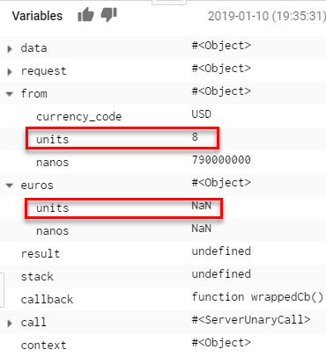

You can conclude that the root cause is a bug in how from.units is converted into euros.units on line 137 and 8 is passed into Data[] which is actually a key value mapping of currency units (like EUR) into exchange rates. The corrected line 137 would use from.to\_currency (aka USD) instead of from.units (aka 8).

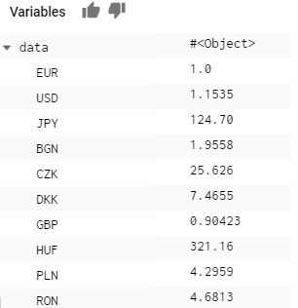

At this point you have determined the cause of the bug and can make the appropriate change. Based on the timing of the alert, this could have been caused by the latest deployment.

See if the previous branch **Master** had this code error on line 137.

Go back to the Console and inspect the code using Cloud **Source Repositories** (in the console menu under Tools).

Open the **apm-qwiklabs-demo** repository and select the **master** branch.

Browse on the left hand side to **src** > **currencyservice** > **server.js**. Notice on line 137 the proper dividend: data[from.currency\_code] is used.

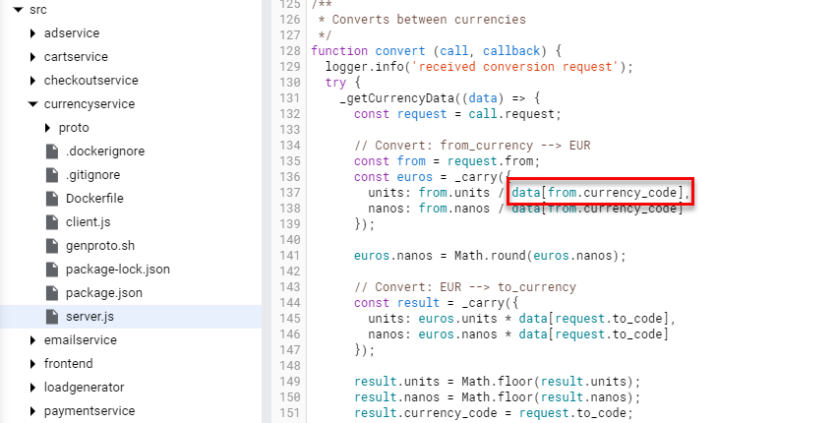

You have confirmation this bug was introduced in the latest push. To mitigate this problem you need to roll back to the previous version.

**Deploy Change to Address Error Rate**

In order to fix this issue, you'll need to deploy a fix to your application. To do that, you'll need to modify the Kubernetes manifest for the service that contained the broken code.

**Deploy Fix**

Return to **Cloud Shell** and in the **Source Code Editor** open the **currencyservice.yaml** file in the **kubernetes\_manifests** folder.

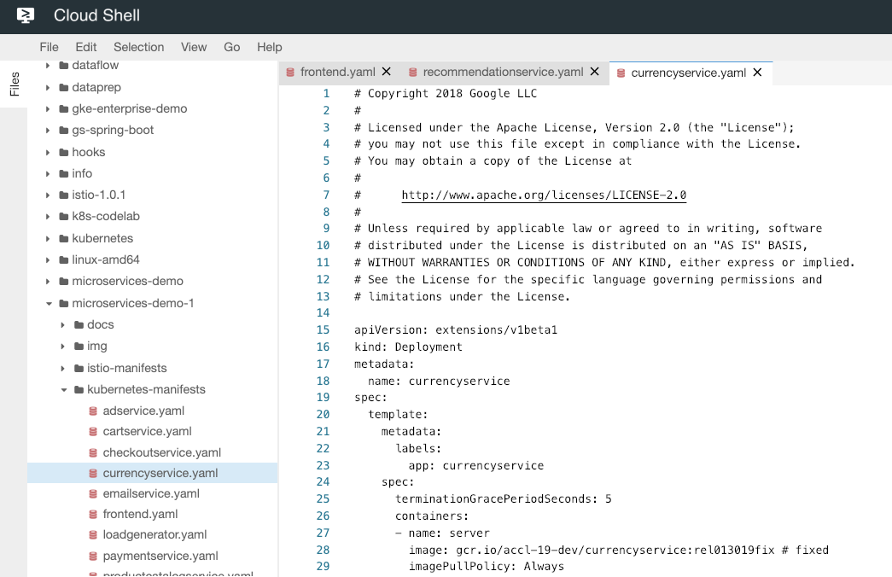

Replace the image tag **rel013019** with **rel013019fix** so the image should look like this:

containers:

- name: server

image: gcr.io/accl-19-dev/frontend:rel013019fix

imagePullPolicy: Always

**Close** the file to save it and **return** to the Cloud Shell prompt.

Redeploy the image with the fix in it:

skaffold run

**Validate Fix**

Now that you've rolled back the breaking change, verify that the application is back to a healthy state.

As before, start by verifying that your incident is resolved. Go to the **Alerting** in the Monitoring UI and verify that the error rate incident is resolved.

Next, return to **Error Reporting**. Open the error previously observed and verify that it is no longer occurring (the timeline should show no further occurrences since the last deployment):

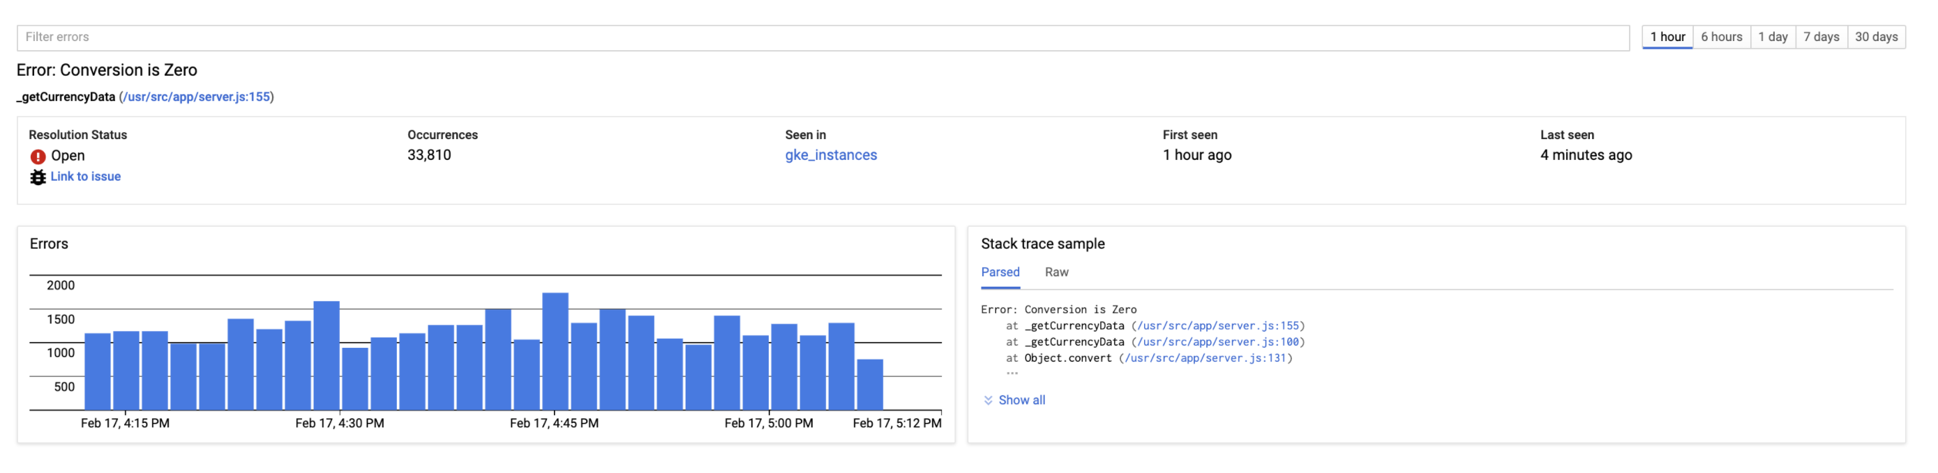

Congratulations - your monitoring was able to correctly identify a change that caused user experience (as measured by application errors) to degrade, you were able to identify the root cause and you've rolled back the breaking change!

Move on to the next section to learn about how you can optimize resource utilization using Cloud Monitoring.

**Application optimization with Cloud Monitoring APM**

In this exercise use Cloud Monitoring Application Performance Management tools (APM) to identify opportunities for improvement that will help your application run faster and use less compute resources.

In this scenario, the Director of Cloud Operations is disappointed with the recent rise in compute costs. Specifically, the **currencyservice** service is using more CPU than expected based on the usage of the system.

Your team has been tasked with finding optimization opportunities. APM tools will be used to analyze the service and ensure your team's efforts are focused on the right areas of the application.

From the Console, open **Profiler** from the left hand menu.

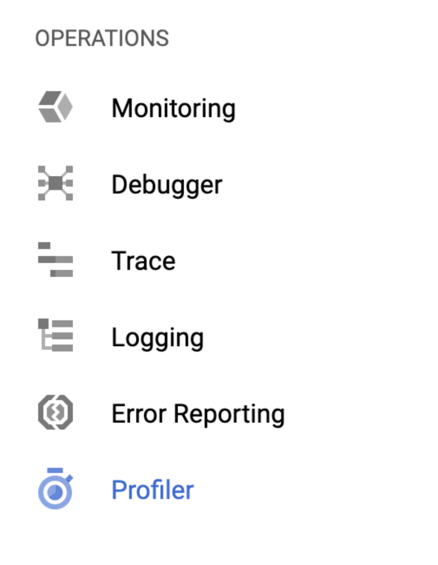

Change the Timespan in the upper right to 30 minutes. If there is no data, wait a minute of 2 for the data to populate.

**NOTE**: Profiler takes a random sample of calls to build an aggregate call stack. If you don't see the data you expect, it's because not enough time has elapsed during this lab and you completed it faster than expected. Feel free to use the screenshots below during the exercise.

In the filter options select the **frontend** service, the **CPU time** Profile type.

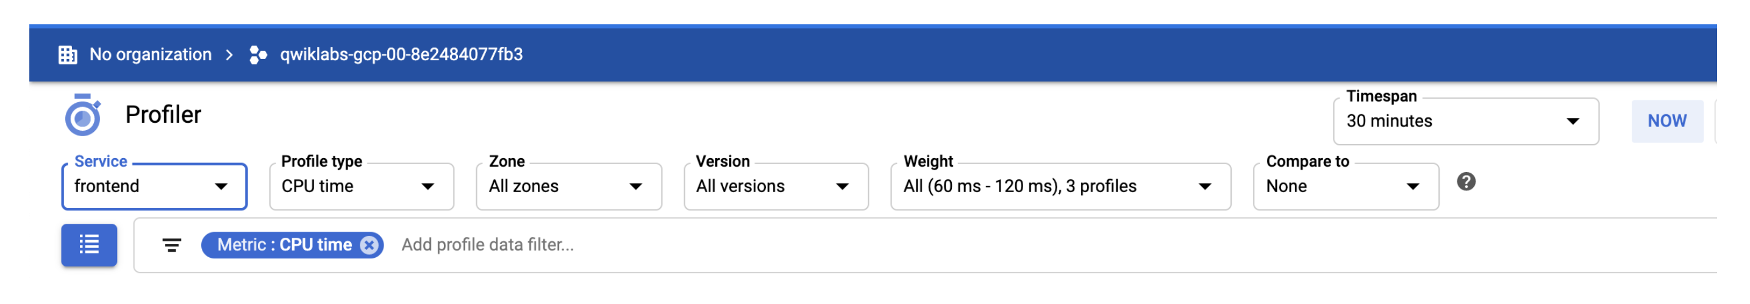

Profiler takes random sample profiles of the system and combines the data to show you what functions are using the most resources. The flame graph below shows the function calls grouped by their use of the resource (in this case CPU) where the X-axis is the amount of CPU and the Y-axis shows parent child relationships.

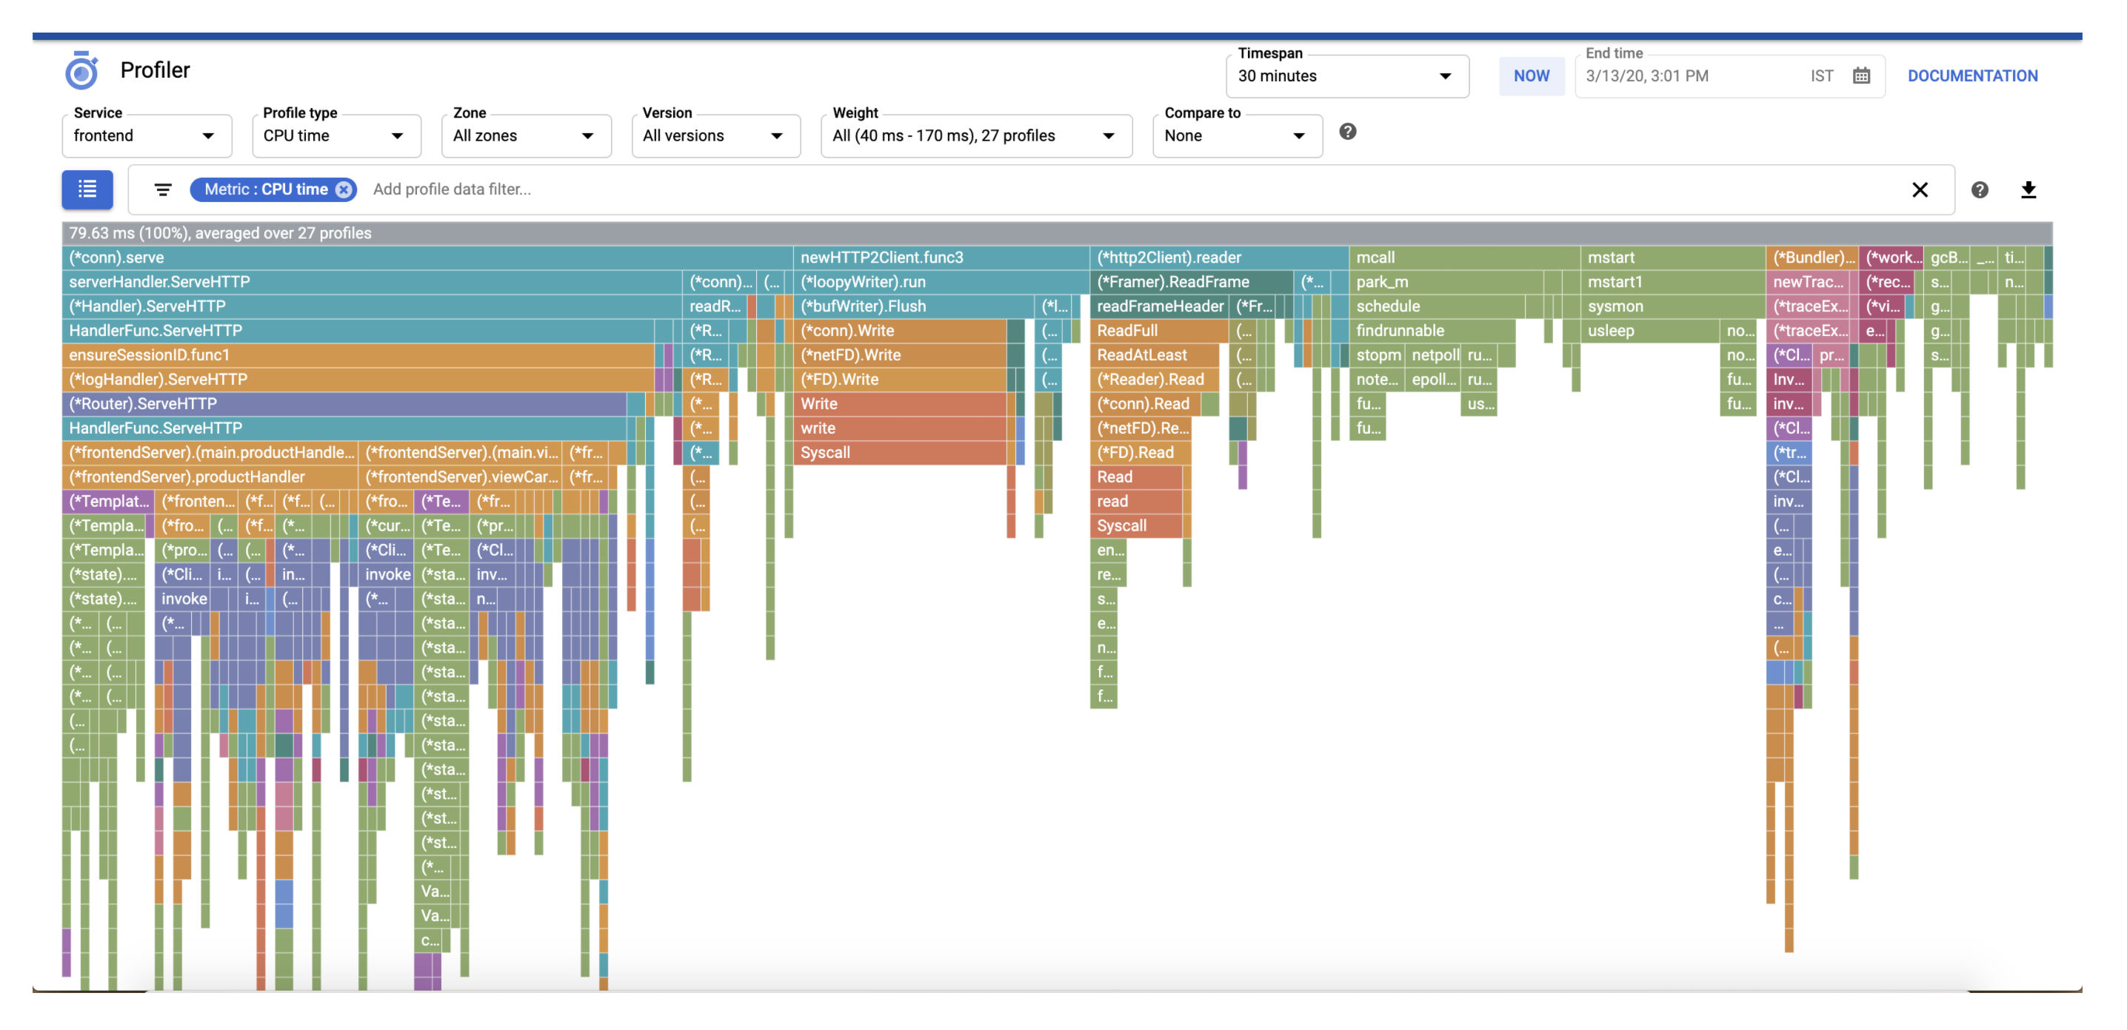

In this case the majority of the CPU is used by the ServeHTTP call on the left hand side. Click on this call to drill into the cause.

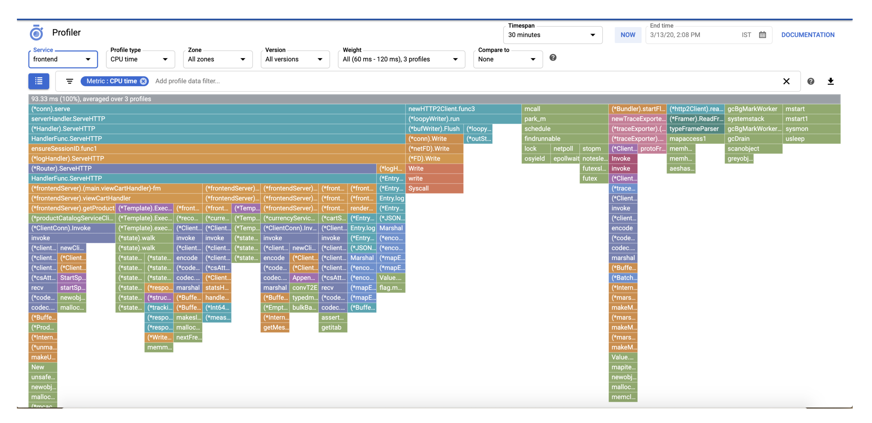

The expanded view shows almost half of this is caused by **viewCartHandler**, which in turn is mostly caused by **getRecommendations**.

The opportunity here is in the **getRecommendations** and in turn **getProduct**. Thinking back to your earlier exercise, remember that the recommendation service and getProduct were being called often in a loop due to an error in retry logic. The resolution for that issue will likely decrease compute cost by as much as 20%.

**End your lab**

When you have completed your lab, click **End Lab**. Qwiklabs removes the resources you’ve used and cleans the account for you.

You will be given an opportunity to rate the lab experience. Select the applicable number of stars, type a comment, and then click **Submit**.

The number of stars indicates the following:

* 1 star = Very dissatisfied
* 2 stars = Dissatisfied
* 3 stars = Neutral
* 4 stars = Satisfied
* 5 stars = Very satisfied

You can close the dialog box if you don't want to provide feedback.

For feedback, suggestions, or corrections, please use the **Support** tab.

Copyright 2020 Google LLC All rights reserved. Google and the Google logo are trademarks of Google LLC. All other company and product names may be trademarks of the respective companies with which they are associated.